**Quandl QA Dev Assessment Question #1:** Using the framework or tool of your choice develop a small test application that tests the following scenarios on our homepage:

* Ensure that the page has only one visible Quandl logo in the top-bar and that it links to the homepage.
* Ensure that a link to the careers page exists on the footer.
* There is a signin/Signup button on the page that when clicked opens a modal. Once the modal opens ensure that you can sign up to a new account.

**Framework/Tools used:** Selenium Integrated Development Environment (IDE)

**Constraints:**  It is a **Firefox plugin** and hence the test scripts below is currently supported for execution only on Mozilla Firefox browser.

**How to install the necessary tools:**

1. Download Mozilla Firefox browser from <http://www.mozilla.org/en-US/firefox/new>.
2. Launch Firefox and navigate to <http://seleniumhq.org/download/>. Under the **Selenium IDE**section, click on the link that shows the current version number.
3. For security, a Firefox notification will pop up. Click on "**Allow**."
4. Wait until Firefox completes the download and then click "**Install Now**."
5. Wait until the installation is completed. In the pop-up window, click "**Restart Now**."

After Firefox has restarted, **launch Selenium IDE** using either of two ways:

* By pressing **Ctrl+Alt+S**
* By clicking on the **Firefox menu button** > **Web Developer**>  **Selenium IDE**

**Location of Video on GitHub:** Quandl\GUI Test\ 2017-02-05_2053_Quandl_GUI_Video

The video capture shows the steps to execute all the test cases step by step. To play the video, Open your web browser on your computer. You can use virtually any web browser to open **SWF** files, including Internet Explorer, Chrome, Safari, Firefox, and others. Click and drag the **SWF** file into your browser window. Release the file in the browser window.

**Pre-Conditions: Make sure you are not signed in as registered user in Quandl.com Website**

**Steps to run:**

1. Launch Selenium IDE and set the Base URL as https://www.quandl.com

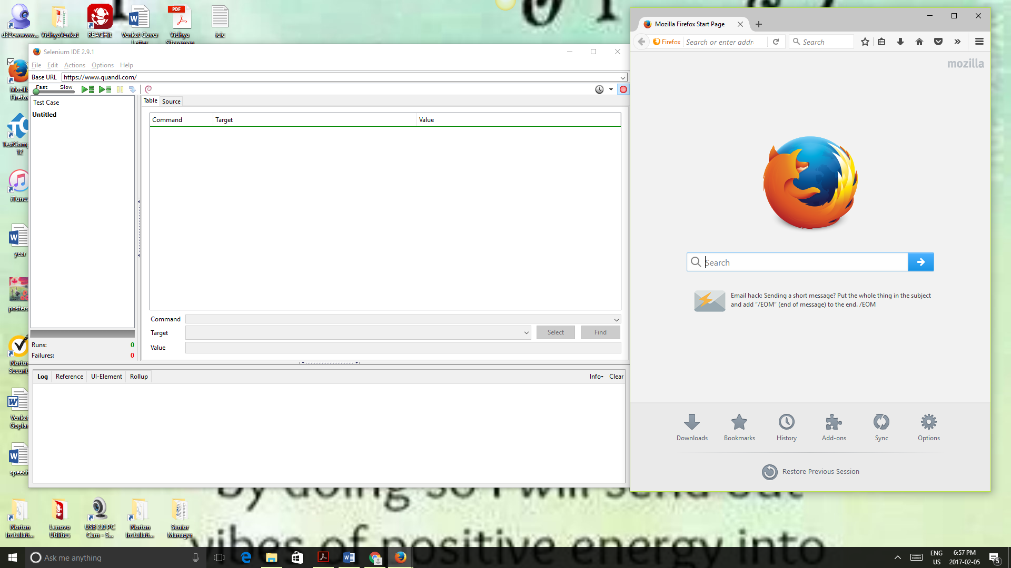

**2.** Load the Entire Test suite file from this location by using File->Open Testsuite and browse to the location where the file resides and click Open.

**Location of Testsuite in GitHub:** Quandl\GUI Test\QuandlTestSuite

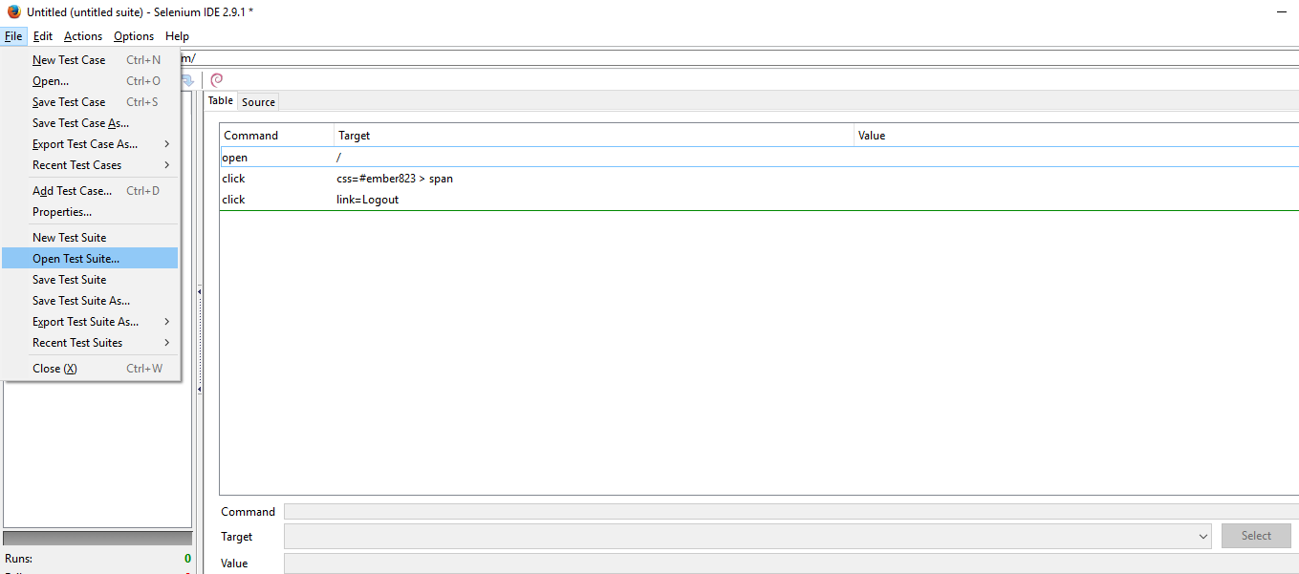

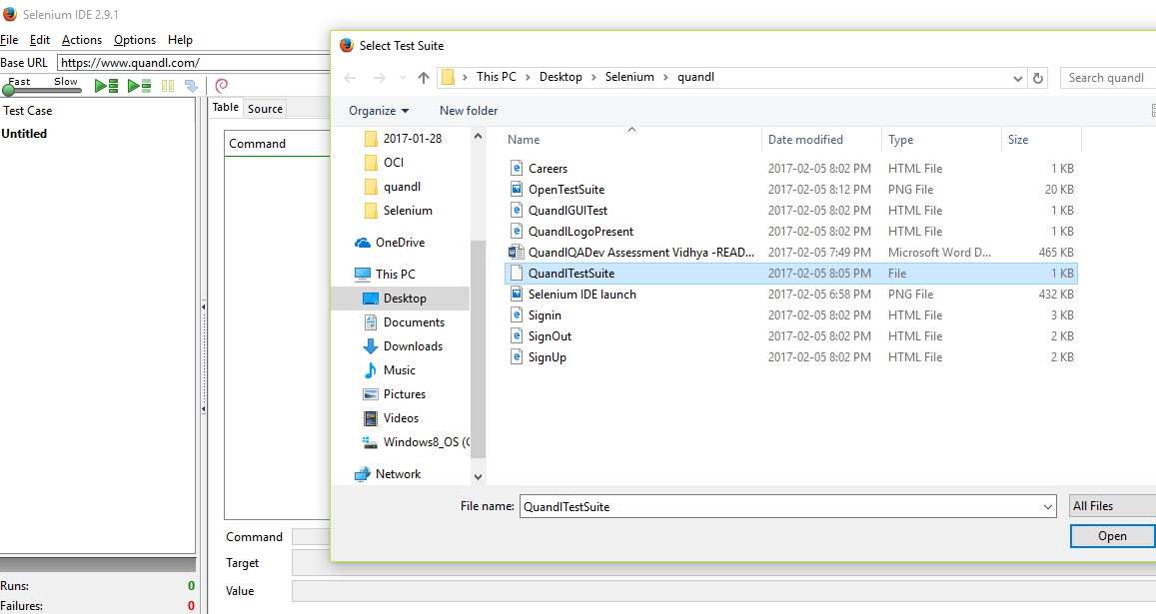

**3.** Go to Actions->Play entire test suite

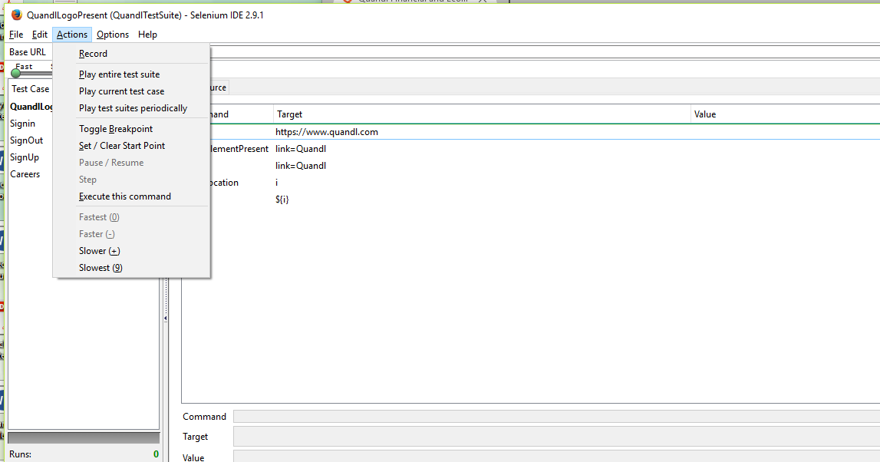

**4.** The QuandlTestSuite has 5 testcases each one to test the specified test scenarios.

**TestCase1 QuandlLogoPresent :** Ensure that the page has only one visible Quandl logo in the top-bar and that it links to the homepage.

**TestCase2 Signin :** There is a signin button on the page that when clicked opens a modal. Once the modal opens ensure that you can sign up to a new account.

**TestCase3 SignOut:** Once signed in ,Sign out.

**TestCase4 SignUp:** There is a signup button on the page that when clicked opens a modal. Once the modal opens ensure that you can sign up to a new account.

**TestCase5 Careers:** Ensure that a link to the careers page exists on the footer.

**5.** Verify the results of the Testsuite in the Log window.

**Note :**

1) The email id and Name used are randomly generated.

2) When clicked on careers and clicked on homepage, the browser url is verified and displayed.